Mental Health and Emotional Wellbeing Policy

Contents

- Policy Statement and Aims - Leadership
- Scope – Ethos and Environment
- Identifying and Monitoring Impact
- Teaching about Mental Health and Wellbeing
- Targeted Support, Referrals and Signposting
- Enabling Pupil Voice
- Staff Development
- Working with Parents/Carers

In addition:
- Warning signs
- Managing disclosures/Confidentiality
- Support Peers
- Policy Review

Date Prepared: March 2025
Date Approved by Governing Body:

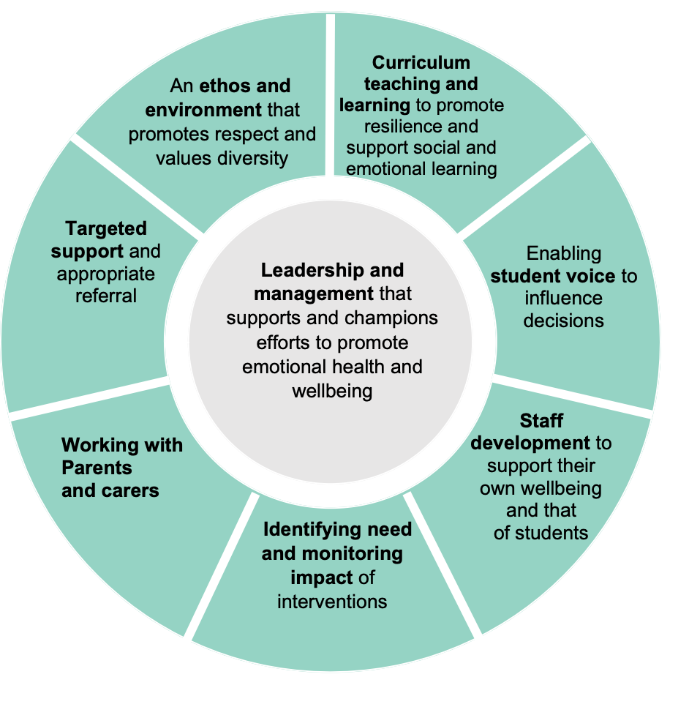

DFE/Public Health England(2021)
https://assets.publishing.service.gov.uk/government/uploads/system/uploads/attachment_data/file/1020249/Promoting_children_and_young_people_s_mental_health_and_wellbeing.pdf

- Policy statement

At Egerton Primary School we aim to promote positive mental and emotional health and wellbeing for our whole school community (children, staff, parents and carers), and recognise how important mental health and emotional wellbeing is to our lives in just the same way as physical health.

Policy Aims:
Our aim is to help develop the protective factors which build resilience to mental health problems and to be a school where:
- All children are valued.
- Children have a sense of belonging and feel safe.
- Children feel able to talk openly with trusted adults.
- Positive mental health and wellbeing is promoted and valued.
- In addition to children’s wellbeing, we recognise the importance of promoting staff mental health and wellbeing

At our school we:

- Help children to understand their emotions and feelings better.
- Help children feel comfortable sharing any concerns or worries.
- Help children socially to form and maintain relationships.
- Promote self-esteem and ensure children know that are valued.
- encourage children to be confident and know that every day matters.
- Help children to develop emotional resilience and manage challenges.

We pursue our vision by:

- Identifying wellbeing as a school priority and having a shared understanding of the term
- Promoting values such as kindness, trust, empathy, respect, equality.
- Having a universal, whole school approach and quality PHSE curriculum to support wellbeing.
- Providing targeted support for pupils’ mental health and wellbeing.
- Providing specialised, targeted approaches aimed at pupils with more complex needs.
- Working with parents and carers.
- Signposting children and families.

2.0 Scope

This policy is a guide to all staff – including non-teaching and governors – outlining Egerton Primary School’s approach to promoting mental health and emotional wellbeing. Embedded with is our commitment to an ethos and environment that respects and values diversity.
It should be read in conjunction with our SEND, Behaviour, Anti-bullying, and PSHE Policies. It sits alongside our child protection procedures. Mental Health and Wellbeing is a priority focus within our School Development Plan.

3.0 Identifying and Monitoring Impact

All children will access a quality first curriculum that teaches social and emotional skills and promotes mental health and wellbeing. This sits within our Jigsaw PHSE curriculum. We will measure children’s wellbeing through observation and pupil voice. This approach enables us to identify any children for may need additional targeted support through Jigsaw Resilience Intervention or through ELSA (Social and Emotional) Learning Mentor Sessions. For those children accessing ELSA – a targeted support pan will be in place, shared and reviewed with parents using our First Concern Paperwork.

4.0 Teaching about Mental Health

The skills, knowledge and understanding our pupils need to keep themselves - and others - physically and mentally healthy and safe are included as part of our PSHE curriculum.

We will follow the guidance issued by the PSHE Association to prepare us to teach about mental health and emotional health safely and sensitively. We use the Jigsaw PHSE Curriculum, The Mindful approach to PHSE. https://jigsawpshe.online/

5.0 Targeted Support and Signposting - Working with Other Agencies and Partners

Each classroom has a wellbeing board with the focus of the termly Jigsaw PHSE Wellbeing. Each lesson has a PHSE and Wellbeing outcome. Each classroom board has visuals and strategies such as an emotional check-in, five point scale to measure feelings with matched strategies to support. Each class has their own Jigsaw friend toy. PHSE lessons have a mindful moment, connect me time, calm me chime and script. There is a termly assembly lead by Mrs Broadbent with support from School Wellbeing Team and Safe and Happy Ambassadors.

We will ensure that pupils, students and parents/carers are aware of the support and services available to them, and how they can access these services. Within the school (Entrance, displays, classrooms, toilets, staffroom ) and through our communication channels (Wellbeing newsletters, website tabs). As part of our identifying need and monitoring impact, as outlined above, they may be times we refer to or gain additional advice or signpost to other agencies, partners and professionals to support children’s emotional health and wellbeing including:

As part of our targeted provision the school will work with other agencies

- The school nurse
- Educational psychology services
- Cheshire East Autism Team
- Cheshire Paediatricians
- CAMHS (child and adolescent mental health service)
- Outreach from Specialist School – Adelaide
- Family support workers
- Identifying and assessing in line with the Cheshire East Early Help Assessment
- The identification, assessment, and support of young carers under the statutory duties outlined in the Children & Families Act 2014.
- https://www.cheshireeast.gov.uk/livewell/care-and-support-for-children/how-do-i-get-early-help-for-my-child/family-information-service/health-and-wellbeing.aspx

6.0 Pupil Voice

At Egerton our aim is also to develop trusting relationships so that children feel safe, happy, respected and valued. We promote pupil voice through developing trusting relationships and providing a rage of opportunities to share and capture views.. Every child is part of an Ambassadors group, where children regularly share their views, plan and contribute. Our Jigsaw PHSE sessions and circle time, together with gathering of pupil voice termly linked to wellbeing will ensure that children’s views are captured and supported.

Key staff members

This policy aims to ensure all staff take responsibility to promote the mental health of students, and that key members of staff have specific roles to play:

- Mental Health and Wellbeing Lead – Mrs Broadbent.
- SENCO – Mrs Broadbent.
- PHSE Co-ordinator - Mrs Broadbent.
- Designated Safeguarding Lead – Mrs Broadbent, Mrs Lowe and Mrs Sedgwick.
- ELSA Emotional Literacy Support Assistant Learning Mentor – Mrs Bagnall and Mrs Bainbridge Sales.
- Teachers – School Team.
- Inclusion Team Teaching Assistants – School Team.
- Wellbeing Team (Team of teaching and non teaching school staff, parents, pupils and governor).
- Safeguarding Governor – Neil McKinlay.

7.0 Training

As a minimum, all staff will receive regular training about recognising and responding to mental health issues as part of their regular SEND/Wellbeing and Child protection training to enable them to keep students safe. Key Members of Staff have received training Mrs Broadbent has completed the Senior Mental Health Lead training. All staff have been trained to deliver the PHSE Jigsaw Curriculum. Key staff across the school have been trained in relational practice and information has been shared with school team to support further.

Training opportunities for staff who require more in depth knowledge will be considered as part of our performance management process and additional CPD will be supported throughout the year where it becomes appropriate due developing situations with one or more students.

8.0 Working with Parents/carers

In order to involve parents/carers we will:

- Ensure that all parents are aware of who to talk to, and how to get about this, if they have concerns about their child.
- Share our tiered approach to supporting wellbeing (1) universal curriculum, 2) targeted intervention (ELSA and REST) (Emotional Literacy Sessions/ Jigsaw Resilience Activities 3) wider support via referrals and advice from specialist professionals.
- Keep parents informed about the mental health topics their children are learning about in PSHE and share ideas.
- Involving parents and carers within our Wellbeing Action Group Team – with parent representatives from across each key stage.
- Make our emotional wellbeing and mental health policy easily accessible to parents.

In order to support parents/carers we will:

- We recognise the family plays a key role in influencing children and young people’s emotional health and wellbeing; we will work in partnership with parents and carers to promote emotional health and wellbeing by:
- Highlighting sources of information and support about common mental health issues through our communication channels (website, newsletters etc.)
- Highlight sources of information and support about mental health and emotional wellbeing on our school website.
- Offering signposting to help parents or carers develop their parenting skills. This may involve providing information or offering small, group-based programmes run by community nurses (such as school nurses and health visitors) or other appropriately trained health or education practitioners.

Additional Guidance

Warning Signs

Staff may become aware of warning signs which indicate a student is experiencing mental health or emotional wellbeing issues. These warning signs should always be taken seriously and staff observing any of these warning signs should alert Wellbeing Lead and Safeguarding Team.

Possible warning signs, which all staff should be aware of include:

- Increase in lateness or absences
- Changes in activity and mood
- Changes in eating / sleeping habits
- Expressing feelings of failure, uselessness or loss of hope
- Any reference to self-harm or suicide
- Lowering of academic achievement
- Physical signs of harm that are repeated or appear non-accidental
- Repeated physical pain or nausea with no evident cause
- Increased isolation from friends or family, becoming socially withdrawn
- Changes in clothing – e.g. long sleeves in warm weather
- Secretive behaviour

Supporting Peers

When a student has mental health and wellbeing needs, it can be a difficult time for their friends who may want to support but do not know how. To keep peers safe, we will consider on a case by case basis which friends may need additional support. Support will be provided in one to one or group settings and will be guided by conversations by the pupil and parent/carers.

14.0 Policy Review

This policy will be reviewed every two years as a minimum.

The next review date is March 2025.

